COMBINED CEOP IMPLEMENTATION PLANNING TEMPLATE

1. RCM identification
Title, acronym: Inter-Continental Transferability Study, ICTS
Starting date: 09/2003
Expected end date: End of CEOP II
URL: http://icts.gkss.de
Chair(s) and term dates: Burkhardt Rockel
Representative(s) to CEOP: Burkhardt Rockel
Contributors: Ray Arritt, Beate Geyer, Bill Gutowski jr., Colin Jones, Zvareh Kotvala, Ana Nunes, Dominique Paquin, John Roads, Eugene Takle, Ulrika Willen, Ayrton Zadra

2. Overall objectives and scientific agenda and background
The Inter-Continental Transferability Study (ICTS) http://icts.gkss.de/ started as a joint project of (1) CEOP,(2) the Water and Energy Simulation and Prediction (WESP) and (3) the GEWEX Hydrometeorology Panel (GHP) Transferability Working Group (TWG). Main objectives of ICTS are to
- Study the transferability of regional climate models to areas of different continental scale experiments (i.e. to different climate regimes)
- Apply CEOP (satellite, reference sites, global analysis and model data) and other available observational data sets to validate the energy and water cycle in regional models
- Assess the influence of different driving global re-analysis
Controlled numerical simulations of regional climates are currently being conducted over areas having fundamentally different climate regimes (e.g., tropical, midlatitude, polar) focused on particular climate characteristics (e.g., monsoons, low-level jets, mesoscale convective systems).In particular,ICTS contributes continuous multiple regional simulations to the CEOP model archive and in turn uses the CEOP global analyses, in-situ, and satellite data to evaluate these regional simulations. The goal of ICTS is to understand the physical processes underpinning the global water and energy cycles through systematic intercomparisons of regional simulations of diverse climates to CEOP observations and analyses.This way the best parameterizations will be localized to simulate certain regional scale meteorological conditions,which we believe will also help to improve future global climate models. For ICTS seven computation areas over the different RHPs were defined. Several aspects were considered in this process (e.g.orography at the boundaries of the simulation areas; inclusion of main typical synoptic features).One area is over the MAGS (Mackenzie GEWEX Study).The second covers GAPP (GEWEX Americas Prediction Project) and was defined by the Project for Intercomparison of Regional Climate Simulations (PIRCS).Another area covering both the LBA (Large-Scale BiosphereAtmosphere Experiment in Amazonia) and the La Plata region was used for a previous South America intercomparison. Over Europe we chose an area that includes the BALTEX catchment,taken from the definition of the CLM area used for the European Union Prediction of Regional scenarios and Uncertainties for Defining EuropeaN Climate change risks and Effects (PRUDENCE) project. The area over Africa covers the African Monsoon Multidisciplinary Analysis (AMMA) region.The area over Asia covers the GEWEX Asian Monsoon Experiment (GAME) region, expanded to cover the Himalayan CEOP reference site.The selection for the MDB (Murray-Darling-Basin Water Budget Project) area was based on a previous case study from the GEWEX Cloud System Study. The horizontal resolution of the regional models was initially chosen to be approximately 50 km. The initial simulation period was from January 2000 to December 2004.Currently the National Center for Environmental Prediction (NCEP) Department of Energy (DOE) Reanalysis II is being used for the lateral boundary condition for these regional simulations.

3. Major results so far
In May 2007 the results from RCM simulations for ICTS are transferred to the CEOP model data archive in Hamburg including data on a common grid from four models and MOLTS from five models.
The group at Iowa State University analyzed the daily cycle of surface parameters for the CEOP EOP1 (July-September 2001). They compared the MOLTS from model simulations against reference data measurements. Results are part of a publication on transferability in BAMS.
Takle, E.S., J. Roads, B. Rockel, W.J. Gutowski Jr., R.W. Arrit, I. Meinke, C.G. Jones, and A. Zadra, 2007, Transferability intercomparison: An opportunity for new insight on the global water cycle and energy budget, Bull. Amer. Soc.
Meinke, I., J. Roads, and M. Kanamitsu, 2007, Evaluation of the RSM Simulated Precipitation During CEOP, J. Meteorol. Soc. Japan
Rockel, B., I. Meinke, L. Roads, W.J. Gutowski Jr., R.W. Arritt, E.S. Takle, and C. Jones, 2005: The Inter-CSE Transferability Study, CEOP Newsletter, 8, 4-5.

4. Status in 2007
Five out of eight models finished the five years simulation (2000-2004) with fixed set up for each of the seven CSE regions. After homogenization and a first check the data has been sent to the official CEOP model data archive at the WDCC (World Data Centre for Climate) Hamburg. Data are stored as MOLTS for the reference sites in 3h temporal resolution. Gridded data on a common lat/lon grid are stored as daily values.

5. Plans for next 2-3 years
Not all model groups have finished their simulations and/or delivered their results yet. Within the next year these groups are going to finish their simulations and send the data to the ICTS archive.
Further analysis of ICTS results will be undertaken. Different groups are going to concentrate on different aspects. These are e.g. investigation on the diurnal and seasonal cycle, simulation of high-time frequency (initially daily timescale) precipitation across seasons and varied climatic regime (as encompassed by the ICTS domains and CEOP data availability).
Besides the various analyses each group is going to perform within the next year(s) there are several options for possible additional simulations which are under discussion:
- different boundary conditions (LBCs)
- variable set up
- higher resolution
- enhanced simulation period (beyond 2004 i.e. for CEOP2, 10 years)
- revision of output parameter list
- additional regions
- update with new model versions
- additional MOLTS

6. Interactions with other Groups

RHPs, WEBS, Extremes, GMPP

7. Planned and potential contributions to the GEWEX roadmap

GEWEX Objective 1: Produce consistent research quality data sets complete with error descriptions of the Earth's energy budget and water cycle and their variability and trends on interannual to decadal time scales, for use in climate system analysis and model development and evaluation.
2008 Documentation and verification of model data sets at the CEOP model data archive for regional model data from ICTS

GEWEX Obective 2: Enhance the understanding of and quantify how energy and water cycle processes contribute to climate feedbacks.
2008 Inventory how regional models simulate flood and drought characteristics using CEOP observations and ICTS simulations
2010 Importance of specification and parameterization of vegetation in simulating wet and dry periods using CEOP observations and ICTS simulations.
2012 Demonstrate the improvements of RCMs regarding the energy and water cycle within CEOP

8. Planned interactions with other research, application and user communities
Include planned meetings, sponsored special sessions at national and international meetings

- Results will be presented on various international conferences an on the official CEOP meetings.
- Informal meetings will be held on international conferences.

9. Other

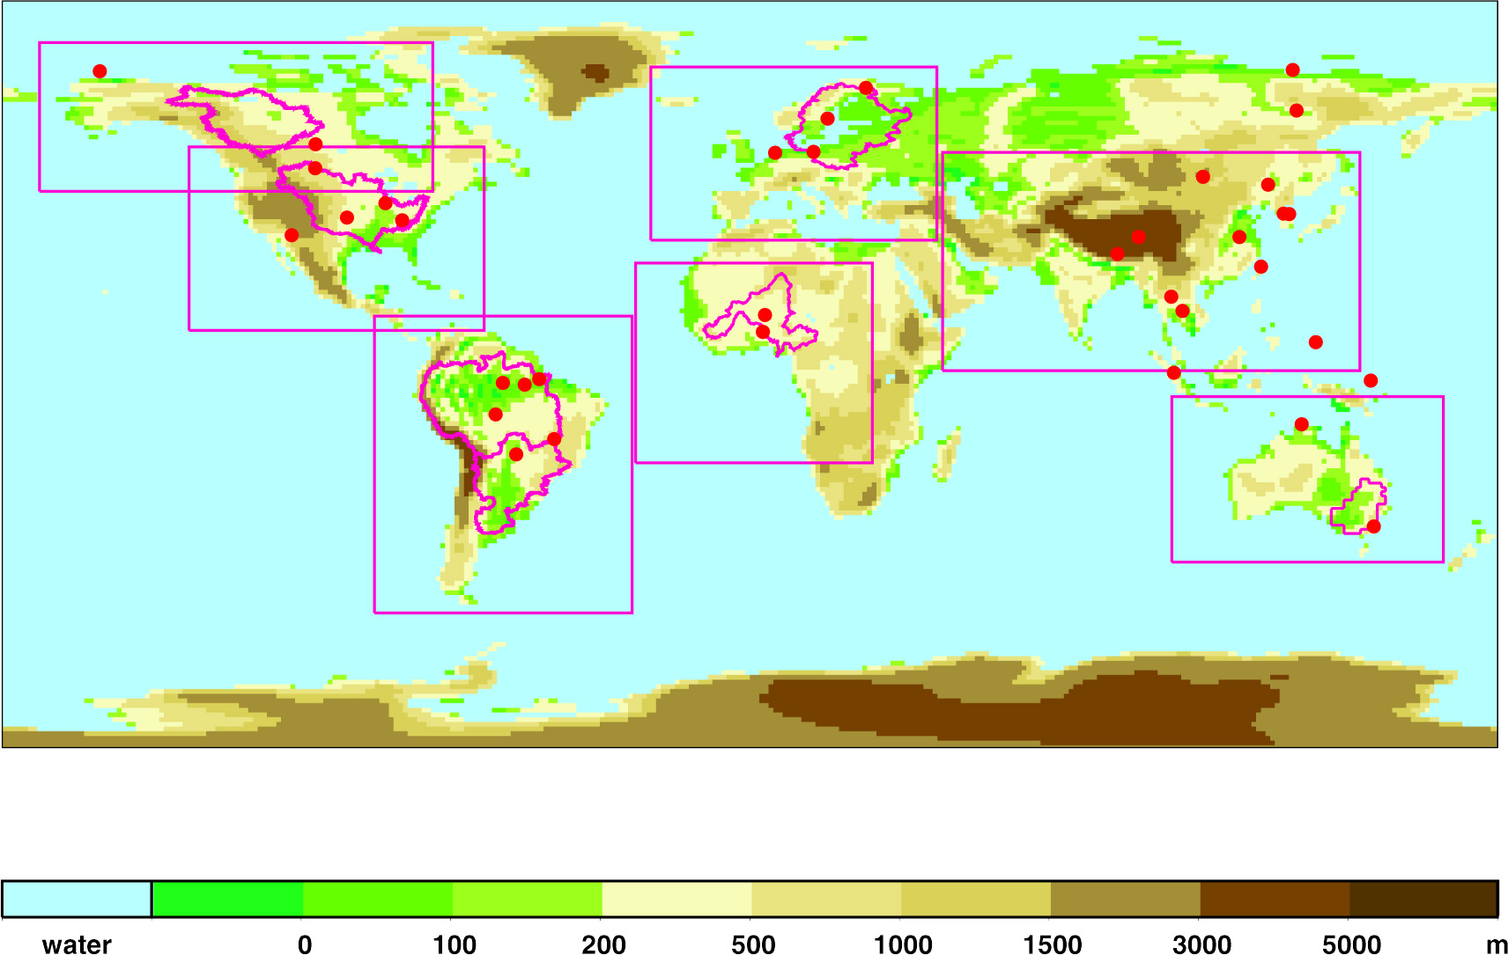

ICTS simulation domains

