BAMEX
Site Survey/Planning Meeting
11-15 November 2002
(Baeuerle, Burghart, Daniels, Lee, Taylor, Tignor)

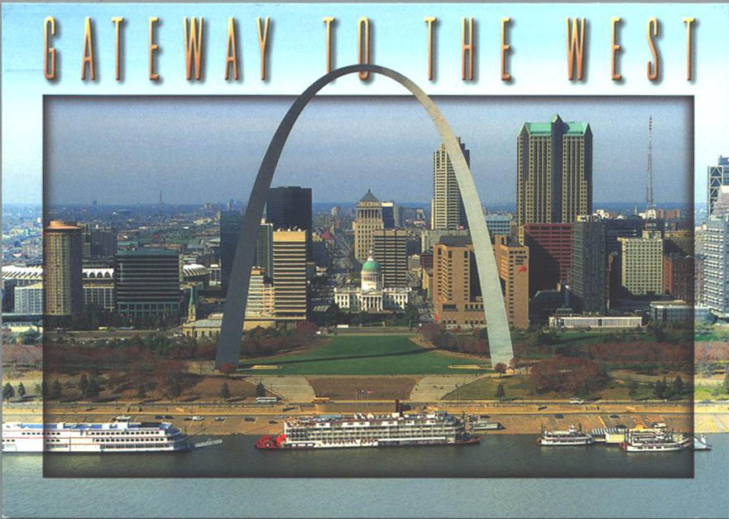

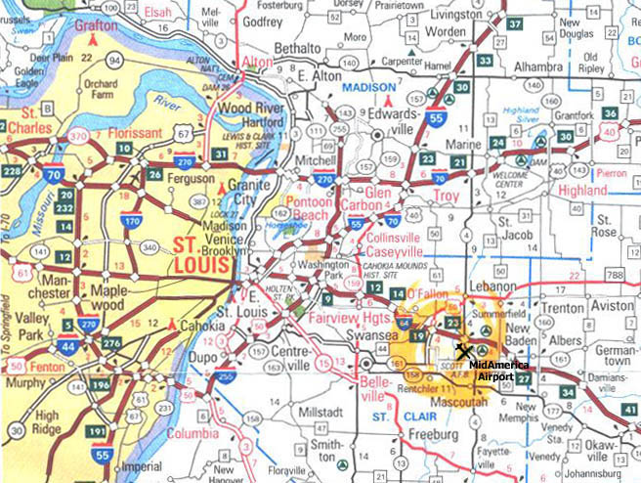
12 November
Site Survey
Lodging

Met with Brad Laspe, of Temporary VIP Suites (office 636-519-1555, fax 636-519-0541, cell 314-629-6630); email blaspe@vipstl.com. We were shown completely furnished corporate apartments at Winchester Place Apartments - 100 Winchester Place, Fairview Heights, Illinois 62208. Two bedroom-apartments include dining area, living room, kitchen, 2 bedrooms, 2 baths; 1- bedroom, 1 bath apartments are also available. All have full kitchen, dishwasher, built-in microwave, garbage disposal, oven/range coffeemaker, and full size refrigerator, some units with washer and dryer. (Washer and dryers are also located for guests at the clubhouse). Complete house wares for kitchen, bath & bedroom, all utilities, local phone & cable included in price. Maid service could be set up on a “weekly” basis. The grounds are fully landscaped with two swimming pools, tennis courts, and lake with fountain surrounded by a walking trail but no fitness center. Directions are I-64E toward Louisville/St.Clair Ave. Take the IL-159 exit – exit number 12 – toward Belleville/Collinsville. Take the ramp toward Belleville; merge onto N. Illinois St/IL 159. Proceed about 2 miles (1.65), past cemetery (Lakeview Memorial Gardens), left into Winchester Place. If you go to Drake Rd, you’ve gone too far. There are several restaurants within “short walking” distance from apartments (Mexican, Pizza/Pasta, Mongolian BBQ, Chinese take out).
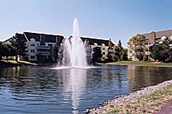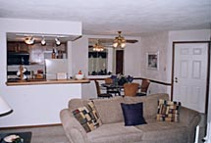

Many restaurants on IL-159, along with Home Depot, Loews, K-Mart, grocery stores, St. Clair Square Mall, etc. Outback Steak House, Bagel Basket, Bakery Thrift Shop, Teachers Sports Bar, Smokey Bones BBQ, Chilies, Sonic and if you’re not into Bagels, there’s a Krispy Kreme donut shop. There are many, many more choices. Mary's Pie Shop in Belleville is recommended by Frank Pratte and Smokey Bones BBQ in O’Fallon is recommended by Al Schanot.

Next we drove to Mid-America Airport. It is located at Exit 23 (Mascoutah/Lebanon, Ill 4). It is 14 miles from the apartments and approx. 16 min driving time. From Exit 12 to Exit 23, it’s about 11 miles. (Tour of the airport on 11/13 - see below.)

From the airport we drove into Mascoutah (4 miles). On Main St. we found the Golden Arches (McDonalds), a Subway, Pizza Hut, Moore’s Restaurant, DQ and Tony’s Place. We had lunch at Tony’s Place. Good menu, chicken and dumplings was the special that day and fresh homemade pies for dessert. They have facilities upstairs to seat up to 60 people. Probably half of Scott AFB was there for lunch.
There is also a Radio Shack, True Value Hardware, Post Office with Fed Ex drop and a golf course...winter rates were $5 for 9 holes.

Following is information obtained at various hotels/motels:

Exit 12- Drury Inn, Fairview Heights. I-64 & Illinois 159, 12 Ludwig Drive Fairview Heights, IL 62208; phone 618-398-8530 (fax same). Res. Online at www.druryhotels.com or 1-800-378-7946. Free Hot Quickstart Breakfast; scrambled eggs, sausage, Belgian waffles, biscuits & gravy and more. M-Th evening (5:30-7 p.m. –when most of you will be flying… beverages and snacks). Coming soon, FREE High Speed Internet Access in all rooms. FREE local phone calls; FREE HBO, ESPN, CNN, etc. Indoor/outdoor pool and whirlpool. Guest laundry room and small fitness center (no weights though). Business Class Kings include microwave and refrigerator @ $65/night (govt). A standard room (no refrig or microwave) @ $55. Two room suites with microwave, refrig and separate bedroom area $80/night. Adjacent Restaurant Bob Evans, within walking distance is a Houlihans, and Olive Garden. Bally Fitness is right across the street. Nearby is also a Super 8, Ramada Inn, Best Western.

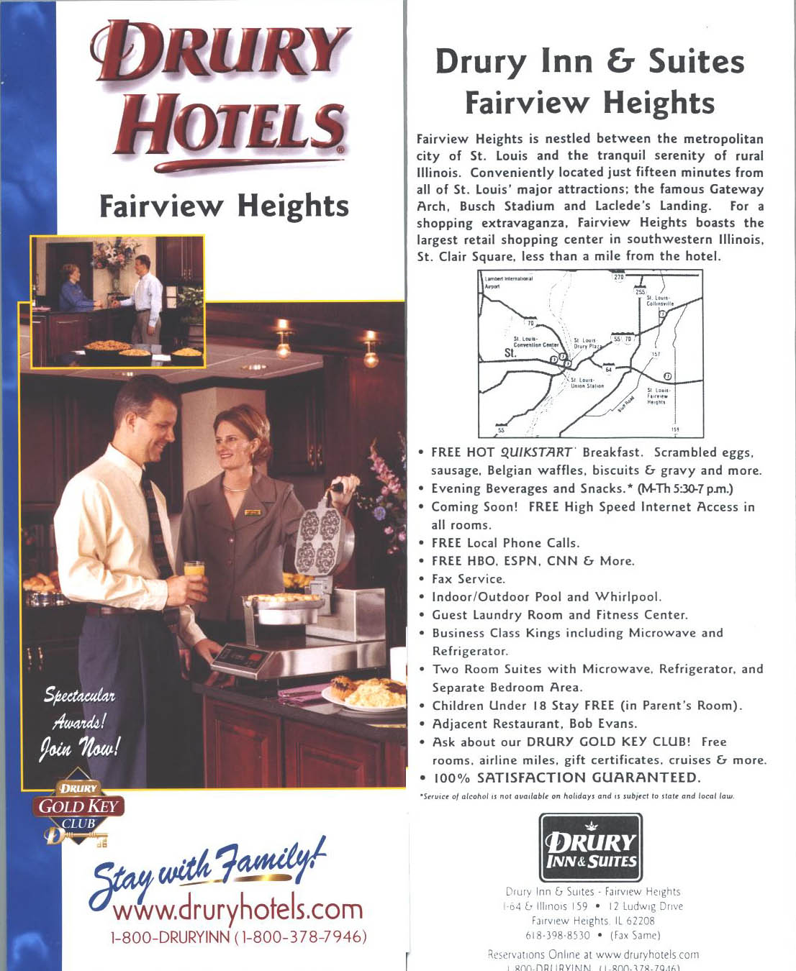

Exit 12 - “Four Points” Sheraton, Fairview Heights. They are located 1 mile North of I-64 and Route 159. They have 120 rooms, high speed Internet; large desk for working, cable TV. The standard rooms would cost $55/night. The rooms with microwave and refrigerator (only 16 units) would cost $75/night. They would be willing to give us approx. 20 rooms as they have to preserve other rooms for Conference Center sponsored events. The Fountains restaurant serves breakfast, lunch and dinner, plus room service. It does have a workout area with about 4 machines. Cocktails are available in the lobby lounge. Within walking distance is the TGIF at the Ramada Inn.
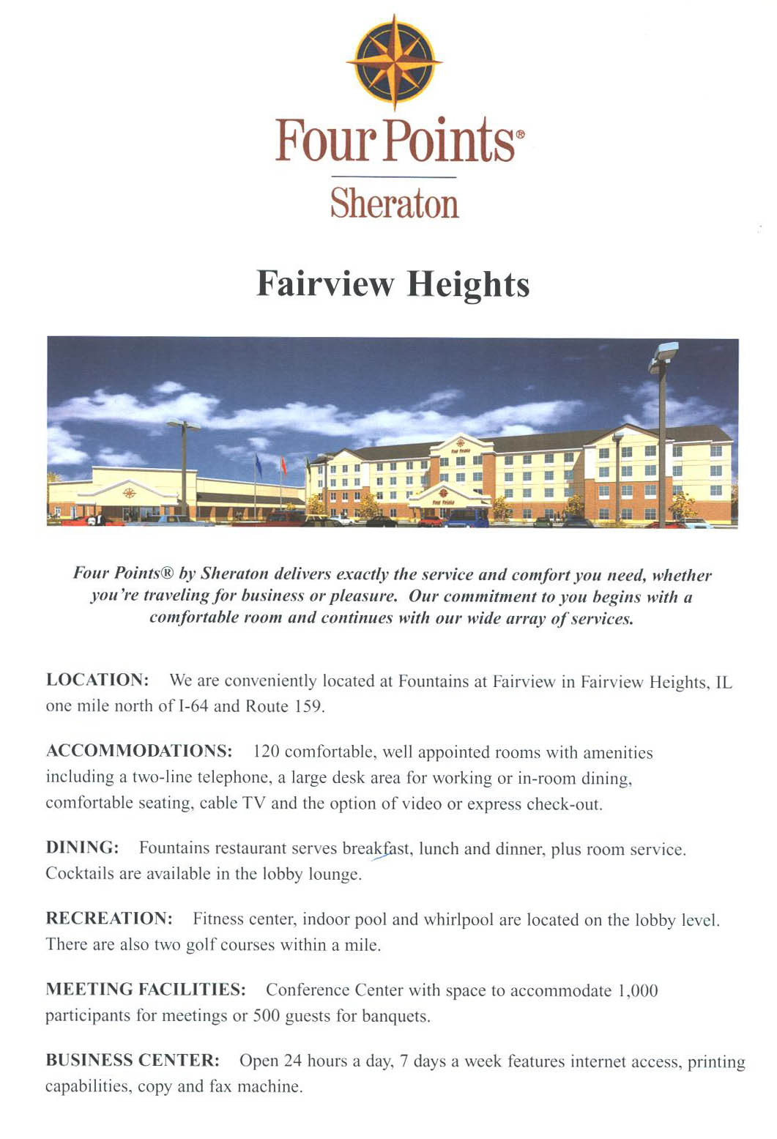

Exit 14: We checked out the Extended Stay America, 154 Regency Park, O’
Fallon, IL 62269; phone (618) 624-1757; fax (618) 624-1778. They have furnished efficiency studios. Fully equipped kitchen with refrigerator, stove top, microwave and coffee maker. Recliner and cable TV; free voice mail and computer data port, free local calls, 24 hr coin operated laundry facilities. Rates by room type: Queen @ $69 nightly or $359 weekly. Double double, $79 nightly, or $399 weekly. King at $75 nightly or $379 weekly. Nearby is SteaknShake; Subway, Brandons, Japanese Garden Steak House; nearby Howard Johnsons.

Exit 14: Baymont Inn, 136 Regency Park; O’Fallon, Il 62269; phone: (618) 632-6668; fax (618) 632-6676. Lots of amenities: complimentary breakfast, in room coffee makers, iron and ironing board, hair dryer, free local phone calls; free cable/satellite movies, 25” TV’s, etc. Executive King Room with microwave and refrig @ $67.50 nightly. In-door swimming pool and small exercise room.

Exit 9: We also checked out the Quality Inn. Although the owner was willing to give us a flat rate of $49, this lodging establishment is older and not quite up to ATD standards.

Also viewed were corporate apartments located in a high rise Mansion House (~29 levels) in St. Louis. Apartments are Studio 500 sqft; Convertible (has a pocket wall separating living/bedroom area 650 sqft, as well as roomy 1 bedroom/1 bath & 2 bedroom/2 baths. All apartments include full kitchen with dishwasher, garbage disposal, coffee maker, and all house wares. Maid service is once a week. There is an exercise facility on site and a pool on the roof (with a nice view of the river and the arch). This is a secure building with free underground parking. Location is ~24 miles from MidAmerica (results in a 25-30 minute drive without traffic).

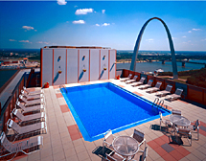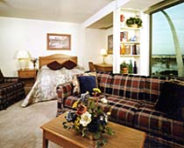

13 November
Site Survey
MidAmerica Airport

Mascoutah, Illinois

MidAmerica Airport shares a runway with Scott AFB. Parking not an issue, as no one is there. There are a couple of security issues due to locked doors and codes/cards will be needed. The Ops Center/Analysis Center will be located in the International Arrival area on the ground floor and daily briefings will be held in the adjacent baggage claim area. The aircraft crews and ATD technicians/engineers will be located is in baggage storage area right next to a staging area near the ramp. This area is quite large but has no windows or air conditioning. There is a secured storage area right next to it. No food service are available at the airport. There is a “kitchen” with a sink, which will be supplemented with refrigerator, microwave, coffee-maker, and hot/cold water dispenser. Other needs: fans (a/c), table & chairs, sofa, cots, bulletin board, gas grills, and heating coil for additional cooking?

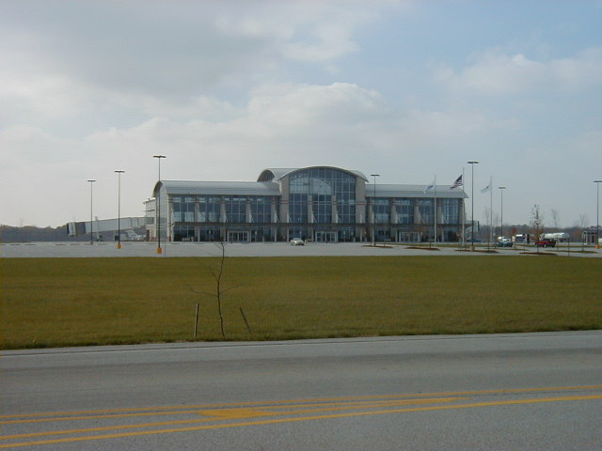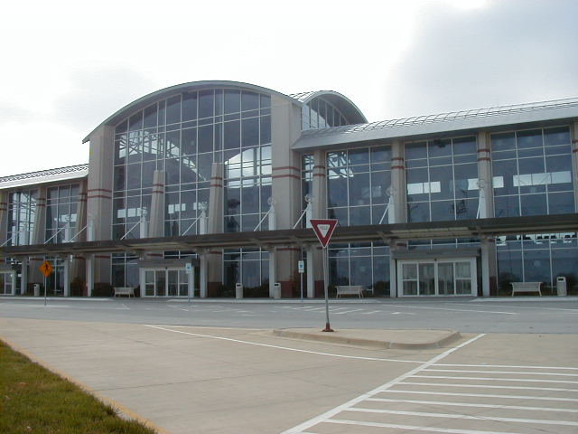

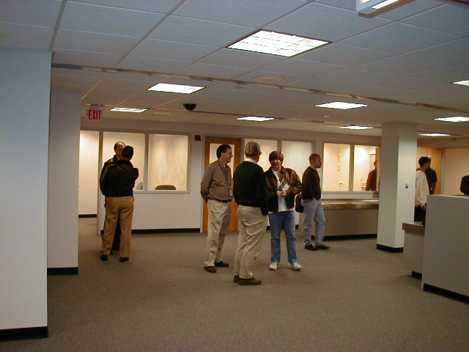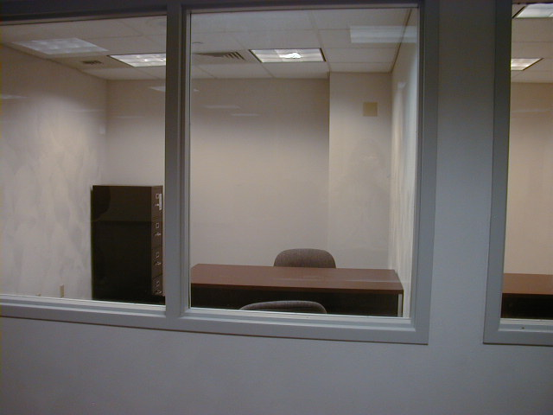

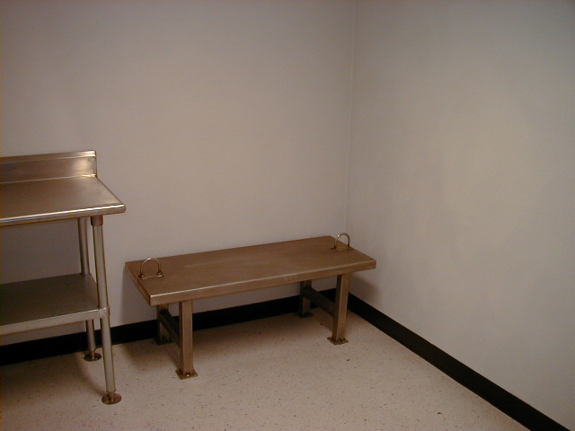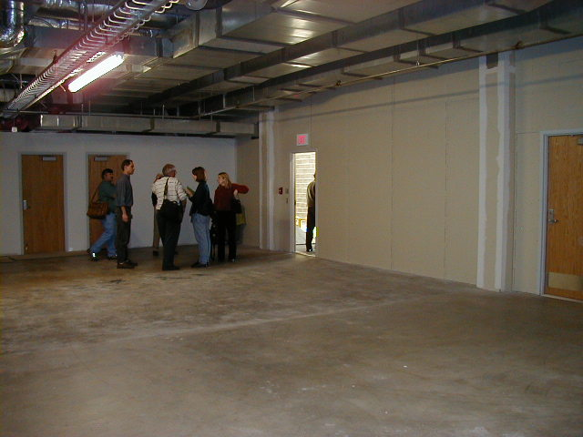

St. Louis Attractions:
The tram ride up 630 ft to the top of the Gateway Arch is well worth the $8 charge. You will enjoy panoramic views (from windows at the top) of downtown St. Louis and East St. Louis. The arch, completed in 1965, with its stainless steel sections is spectacular at all times of the day, including late evening. Laclede’s Landing, now restored warehouses with many restaurants, nightclubs, and bars along cobblestone streets, and was once a bustling port down by the waterfront in the early 1800s. Catch a Cardinals game, listen to Blues or Jazz in Soulard, tour Anheuser-Busch or get your kicks on Rt.66; there’s plenty to see and do.

