Map of all ISFF Sites
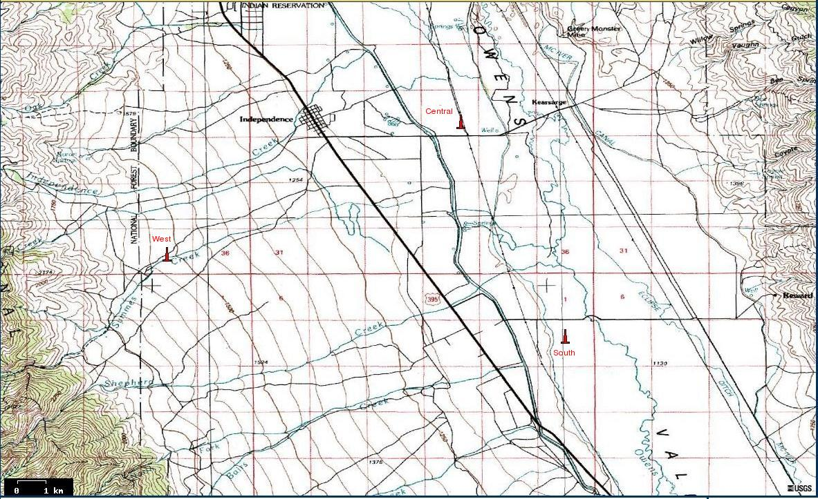
Central ISFF Site:
Lat: 36d 48.091'N Lon: 118d 09.601'W (WGS84 datum) Elev: 1155m
Legal Description: T.13S, R.35E, Section 15.

Directions from 395&Market:
- Approx 0.2mi S on 395
- Turn left on Mazourka Canyon Rd,
- 2.0mi turn left, bear right to cell phone tower
- Continue approx. 450m (0.25mi), keeping barbed wire fencing to your left, less than 0.1mi after passing tower
- Orange flagging is to right of track. Second orange flagging is approx 60m to NE.

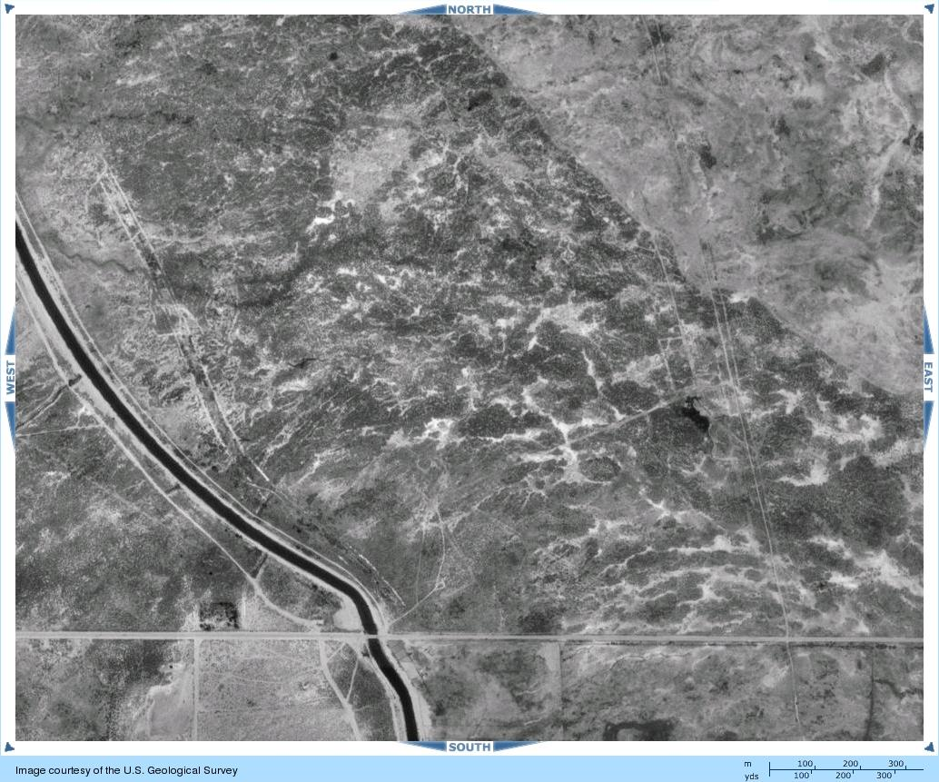
Existing
Cell Phone
Tower
Central ISFF Site
Mazourka Canyon Rd.
Tower

Central Site:

1 x 110 foot tall lattice type tower, with electronic sensors at various heights from ½ foot to 100 feet.

1 x 36 foot tall lattice type tower, with solar radiation sensors at 32 feet.

1 x 18 foot tall lattice type tower, with electronic sensors at various heights from ½ foot to 10 feet.

3 x 6 foot tall sawhorse type structures with solar radiation sensors.

1 rain gauge and multiple soil sensor locations.

A five strand barbed-wire fence surrounding the perimeter.
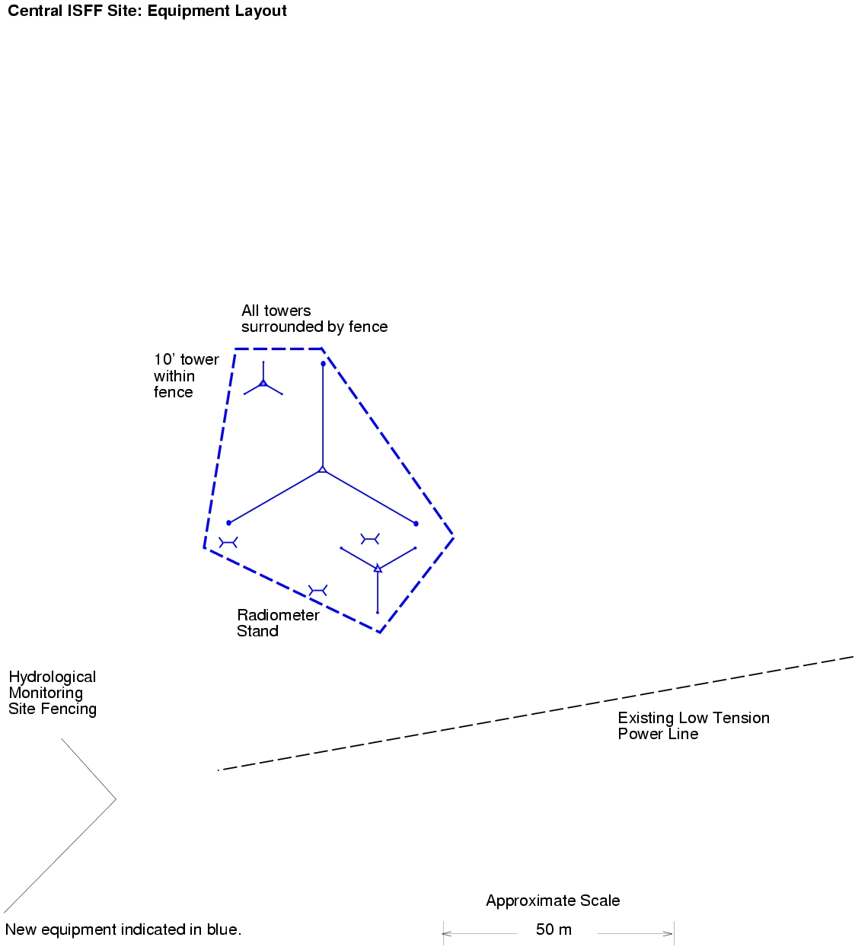
South ISFF Site:
Lat: 36d 44.054'N Lon: 118d 07.282'W (WGS84 datum) Elev: 1141m
Legal Description: T.13S, R.35E, Section 15.

Directions from 395&Market:
- 5.5 (5.7?)mi S on 395
- Turn left on Manzanar/Reward road,
- 1.4mi turn right, crossing narrow cattle guard
- 0.6mi turn left at orange flagging. Tower base is ~50m to ESE.

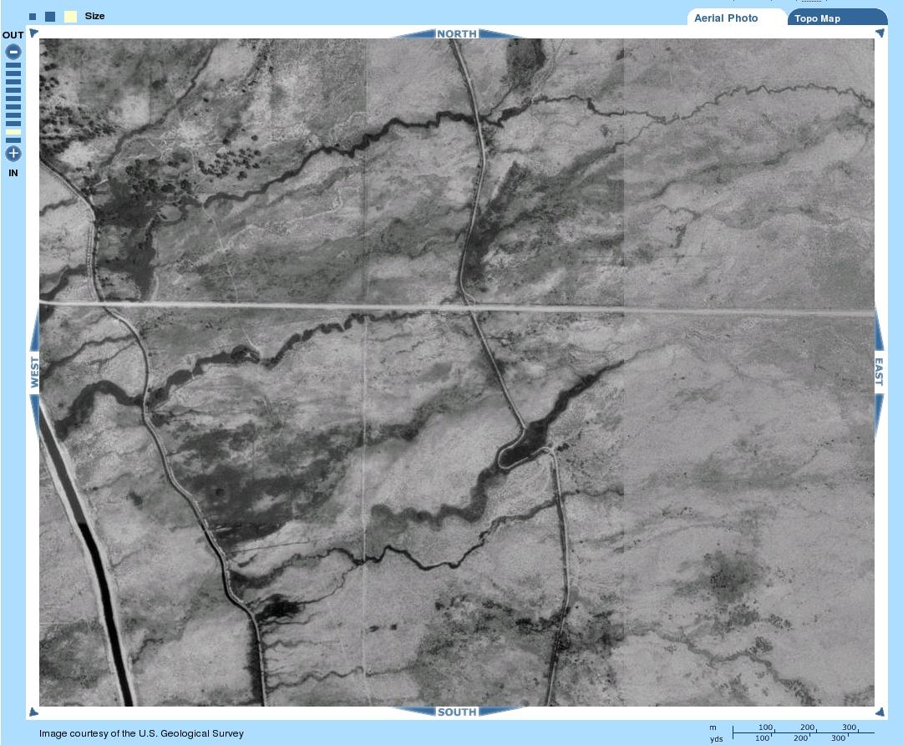
Manzanar/Reward Road
Tower
Site
South ISFF Site
South site:

1 x 110 foot tall lattice type tower, with electronic sensors at various heights from ½ foot to 100 feet.

1 x 6 foot tall sawhorse type structure with solar radiation sensors.

A five strand barbed-wire fence surrounding the perimeter.

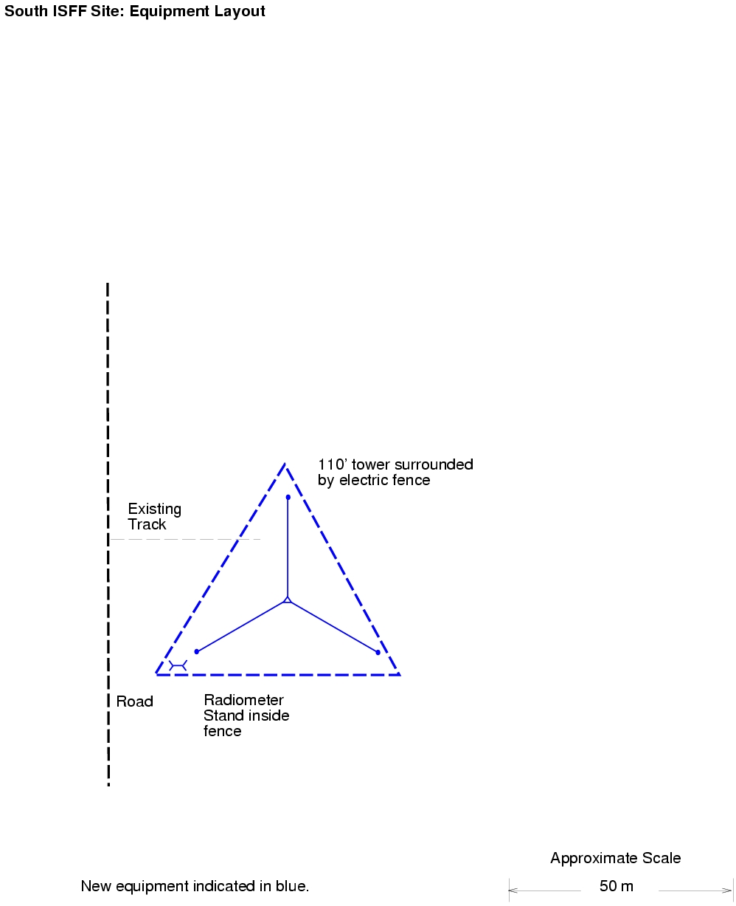
West ISFF Site:
Lat: 36d 45.595'N Lon: 118d 14.842'W (WGS84 datum) Elev: 1529m
Legal Description: T.13S, R.35E, Section 15.

Directions from 395&Market:
- 4.3mi W on Market St. (becomes Onion Valley Rd.)
- Turn left on Foothill Rd. (gravel)
- 1.2mi bear left on secondary dirt road
- 0.4mi, turn left on another dirt road
- 0.5mi, flagging on left, opposite “menhir” rock on right
- SE tower guy is ~10m N.
- Turn-around at entrance to “camp”, approx 100m further on right.
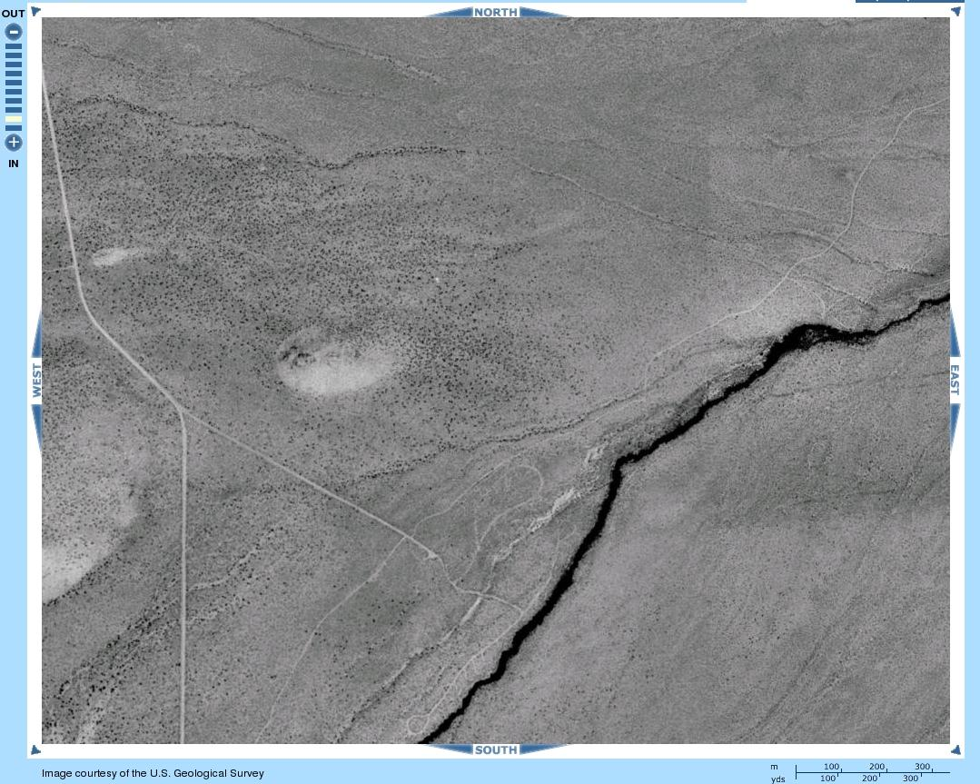
Existing
DRI site
Tower
Site
West ISFF Site

West site:

1 x 110 foot tall lattice type tower, with electronic sensors at various heights from ½ foot to 100 feet.

1 x 6 foot tall sawhorse type structure with solar radiation sensors.

A five strand barbed-wire fence surrounding the perimeter.
